

Project Report
DESIGN OF EXPERIMENTS - IEE 572

Design of an Experiment to
Optimize the Factors Affecting the Performance of a Swimmer

Instructor: Dr. Douglas C. Montgomery

Team: E-Mail:

Kiran Sattiraju sattiraju@asu.edu
Gopi Krishna Gunturu gopi_gunturu@asu.edu
Suman Challagulla chsuman@asu.edu

CONTENTS
Acknowledgement
Executive Summary
Motivation for the Project
Abstract
Recognition and Statement of the Problem
Choice of Factors, Levels and Ranges
Selection of Response Variable
Design of the Experiment
Number of Replicates
Performing the Experiment
Statistical Analysis of the Data
Verification of Normality
Analysis of the Half Normal Plot
Analysis of the Normal Graph
Analysis of Variance (ANOVA)
Regression Model
Analysis of the Residual Plots
Conclusions
Recommendations
Future Scope of Work
Appendix
EXECUTIVE SUMMARY:
Motivation for the project:
Five times Olympic Champion Tracy Bonner said “if you want to be a better swimmer, then swim”. Then, “How should one practice?” would be the obvious next question. In this project, we have tried to find an answer to this question by means of an experimental analysis.
Abstract:
The way in which we proceeded to do this project was to conduct a designed experiment on a particular swimmer considering the different factors that we thought would influence his performance. A full factorial experiment with a single replicate was conducted and the data was analyzed using “Design Expert” package. The details of the data and data collection, choice of factors and levels, response variable, experimental design, performing the experiment and the analysis are included in the report.
RECOGNITION AND STATEMENT OF THE PROBLEM:
Performance of a swimmer is measured by the time taken by him to complete a particular distance. Our objective was to find out what factors affect the performance of a particular swimmer. We wanted to find the levels of these significant factors at which the swimmer takes the least time to complete swimming a particular distance. For our experiment, we chose the distance to be 20 meters. This particular distance of 20 meters was chosen because the experiment was performed in the Terrace Apartments swimming pool and the length of the pool was 20 meters.
First of all, the pre-experimental analysis was done. We stated our problem, choose the factors, their levels and ranges and we selected the response variable. This is discussed in more detail in the discussion below.
Our objective can be summarized as follows:
Objective: To reduce the time taken to swim a distance of 20 meters by a particular swimmer.
CHOICE OF FACTORS, LEVELS AND RANGES:
After talking to a few people who practiced swimming regularly, we came up with a list of factors that may affect the performance of the swimmer. The factors were:
- The time of the day
The swimmer may swim in the morning or afternoon. So the two levels in this factor would be:
- Morning
- Afternoon
- Food:
The swimmer may or may not consume food before he comes to swim. So the two levels of the factor are:
- Swimming after consuming food
- Swimming without consuming food
- The end from which the swimmer starts:
The swimming pool, obviously, has two ends. The end that is deeper (about 8 meters usually) is called “Deep End” and the end that is not deep and is usually just one meter deep is said to be the “Far End”.
The swimmer may either choose to start from either the deep end or the far end. So the two levels in this factor are:
- Starting to swim from the deep end
- Starting to swim from the far end
- Type of swimming wear
The swimmer may wear a swimming trunk and goggles for comfort or he may just wear some casual shorts. But we are not interested in this factor. So this is a nuisance factor. The factor is known and controllable. So we decided to block it.
So the two levels in this factor, which we want to block, are:
- Swimming with trunk
- Swimming with a casual shorts
In order to block the effect of this factor, we measured the response variable in all the runs in each of the block levels in a randomized fashion.

Cont…

There are some other factors that are constant:
- Temperature of water
A heater controls the temperature of the water in the pool and so the experiment is conducted when the swimmer swam in the water in which was at a constant temperature.
- The style of swimming
The swimmer that we have selected can swim only in the “free style” way of swimming. So the entire experiment is conducted when the swimmer swims in “Free Style”.
SELECTION OF THE RESPONSE VARIABLE:
Our objective was to optimize the factors that affect the performance of the swimmer. So we have to minimize the time taken by the swimmer to swim from one end to another. In order to do this, we have to measure the time taken by the swimmer to swim the length of the pool. So we selected the response variable to be the time taken by the swimmer to swim the length of the swimming pool.
DESIGN OF THE EXPERIMENT:
Choice of Design:
There are three main factors to be considered in this experiment as described above. Each of the factors has two levels. Hence, We decided to go for the 2^{k} factorial design (k = number of factors = 3). Hence, we have to consider a total of 2³ (= 8) effects which involved the main factors and their interactions – both second order and third order. We have to block the effect of the factor: “Type of swimming wear”. This factor has two levels because the swimmer can swim in casual shorts or a swimming trunk. In order to block the effect of this factor, we have to measure the response variable for each of the treatment combinations in both the levels of this block.
Number of Replicates:
We have used the design expert to decide the total number of replicates for the experiment. By a trial and error method of selecting the replicates and plugging them into the design expert software, we found that the Second Standard Deviation was 92.7% for 2 replicates (See Appendix 3). Hence we decided to conduct the experiment with two replicates.
Hence our experiment can be summarized as a 2³ full factorial design with two replicates. The data is shown in Appendix 1.
PERFORMING THE EXPERIMENT:
The experiment was conducted in the swimming pool in the Terrace apartments. The time taken by the swimmer was recorded by using a stopwatch.
The experiment was conducted in the early morning at 7.30 A.M and afternoon 12.30 P.M. The food that is consumed by the swimmer was a standard calorie diet 30 minutes before performing the experiment. After noting down the time taken by the swimmer to swim for one end to the other for one particular treatment combination, he was allowed to rest for 20 minutes to regain the normal heart beat. Then the second reading was taken. keeping the fatigue of the swimmer in mind, only two readings per session were taken. The randomized Run Order is as shown in Appendix 1.
STATISTICAL ANALYSIS OF THE DATA:
The analysis of the collected data was done using “Design Expert” and “Minitab” analysis packages. Our hypothesis was as follows:
H₀: τ₁ = τ₂ = τ₃ = 0
H₁: τ_{i} ≠ 0 for at least one i
Here, the τ’s represent the treatment means.
Verification of Normality:
The data was tested for normality using “Mintab” package. The normality probability plot was plotted and it was found that the data was normally distributed. The normal probability plot is shown in appendix 2:A
Analysis of the Half Normal Plot:
The half plot was plotted and from that we see that the factors “Food” and “Deep/Far end” are significantly away from the straight line. Thus we can conclude that they are not normally distributed with a mean of zero and constant variance. So, we can say that they are significant. The effect of the other main factor “Time of the Day” and the interaction effects are fairly near to the line and can thus we can conclude that they are normally distributed with a mean of zero and a constant variance and do not have significant effects. The Half-Normal plot is shown in Appendix 2:B
Analysis of the Normal Graph:
The normal graph was plotted and analyzed for finding out the significant factors. After analyzing the normal graph, we found that the effects “Food” and “Deep/Far End” were the only effects that were significantly away from the straight line. So, we concluded that these factors were not distributed with a mean zero and a constant variance. So, these two effects were the only two effects that were significant. The Normal Graph is shown in Appendix 2:C
Since the factors “Food” and “Deep/Far end” were significant, we had a doubt that their interaction was also significant. Hence, we included it in the model and tested its P-Value. It was found about 0.45, which was pretty high. The value of “PRESS” was also studied. When the effect of the interaction was included, the value of PRESS was 13.57 and when the interaction effect was not included, the value of PRESS was found to be 12.57. So, we felt that it was reasonable enough to conclude that it was insignificant and hence, we left it out of the model.
Analysis of Variance (ANOVA):
After studying the “Half Normal plot” and the “Normal graph”, we proceeded with the analysis if variance. The insignificant terms were taken out of the model and the ANOVA table was obtained from “Design Expert” package. The model had two degrees of freedom, which comprised of one degree of freedom for each of the significant effects. The block had one degree of freedom and the residuals had twelve degrees of freedom. The total correlative degrees of freedom were fifteen. The value of the Type I error was assumed to be 0.05. The ANOVA table is shown in Appendix 4.
From this table, we found the P-Values of the effects of the factors “Food” and “Deep/Far End” to be less than 0.0001 and 0.0229 respectively. They were both less than 0.1. This proved that both of them were significant. Also, the P-value of the model was found to be less than 0.0001, which suggested that the model was significant. The model F-Value of 26.25 implies that the model is significant. Hence, we reject the null hypothesis and conclude that at there is at least one factor that is affecting the performance of the swimmer. There is only a 0.01 % chance that a “Model F-Value” this large could occur due to noise. The “Predicted R-Squared” value of 0.6693 is in reasonable agreement with the “Adjusted R Squared” value of 0.7830. “Adequate Precision” measures the signal to noise ratio. A ratio greater than 4 is desirable. Our ratio of 14.671 is an adequate signal. All these values are shown in Appendix 5. This model can be used to navigate the design space.
Regression Model:
After the analysis of variance, we studied the regression model that as obtained from “Design Expert” package. The regression model equations were found to be as given below:
Final Equation in Terms of Coded Factors:
Time Taken = +17.08 +1.28 * B + 0.49 * C

Final Equation in Terms of Actual Factors:
Time Taken =
+17.08062 +1.27562 * Food +0.49187 * Deep/Far End
From the regression equations, we can predict the amount of time that the swimmer would take to swim from one end of the pool to the other for a particular situation. We see that the coefficients of both the factors in the equation are positive. So, this leads us to believe that higher levels of the factors would result in increasing the swimming time and that the lower levels of the factors would result in reducing the swimming time.
Analysis of Residuals:
After the Analysis of variance and the Regression model, we analyzed the residual plots.
The Normal plot of the residuals was plotted and the plot showed that almost the residuals would pass the fat pencil test, which proved that the residuals were normally distributed. The plot is shown in Appendix 6:A
The Residuals Vs Predicted values graph was plotted. We wouldn’t say that the graph was very ideal but since our experiment was a 2³ factorial experiment with two replicates and we had only a total of only sixteen readings, the graph was just satisfactory. The plot is shown in Appendix 6:B
The Residuals Vs Run Order was also plotted and this graph also had the same characteristics. Even though we ran the experiment according to the random order that the “Design Expert” package gave us, we wouldn’t say that this graph was very ideal. This is because it resembled a vague inverted “S” shape. But again, since our experiment was a 2³ factorial experiment with two replicates and we had only a total of only sixteen readings, we would say that the graph was just satisfactory. The plot is shown in Appendix 6:C
The Residuals Vs Factor graphs were also plotted and for both the significant factors, we found that the residuals were symmetric about the mean and this suggests that the residuals were normally distributed with a mean of zero with a constant variance. The plots are shown in Appendix 6:D, 6:E
The Histogram and the Box Plot of the residuals was plotted in the “Minitab” package and they supported our assumption that they were normally distributed with a mean of zero.
The Outliers Vs Run Order graph was plotted and this showed that there weren’t any significant outliers. The plot is shown in Appendix 6:F
CONCLUSIONS:
From the Analysis of Variance table, we found that the value of the F-Statistic to be 26.25 and its P-Value to be 0.0001. The large model F-Value of 26.25 and its small P-Value of 0.0001 implies that the model is significant. There is only a 0.01 % chance that the model F-Value so large could have occurred due to noise.
The “Predicted R-Squared” value of 0.6693 is in reasonable agreement with the “Adjusted R Squared” value of 0.7830. The “Adjusted Precision” value of 14.671 is far above than 4 and so it is an adequate signal to noise ratio.
From the analysis of the “Half Normal Plot” and the “Normal Graph”, we found that the factors “Food” and “Deep/Far End” were significant. This was further supported by the fact that the P-Values of these two factors was far less than 0.1. The other main factor “Time of the Day” and the two factor interactions and the three factor interaction were found to be insignificant.
From the Model Graphs plotted in “Design Expert”, we plotted the graphs of the Response Variable Vs Significant factors. When the graph of the “Time taken Vs Food” was plotted, we found that the graph was linear and that the time taken to swim increased when the swimmer took food rather than when he did not take any food. We tried to analyze why the swimmer took lesser time when he did not take any food. After the swimmer was questioned, we found a reasonable answer to this questioned. The swimmer felt that he should be given more than 30 minutes of time between taking food and swimming. He also said that he got tired when he swam after eating. The graph is shown in Appendix 7:A.
Similarly, we plotted the “Time taken Vs Deep/Far End” was plotted, we found that the graph was linear and that the time taken to swim increased when the swimmer started from the Far end rather than the Deep end. In this case also, we tried to analyze why the swimmer took lesser time when he swam from the far end. When the swimmer was questioned about this, he said that starting to swim from the Deep end was more difficult than starting from the Far end. So, that explained why he swam more quickly when he started from the Far end than when he started from the Deep end. The graph is shown in Appendix 7:B.
From a rough analysis of our collected data, we found that the swimmer took lesser time when he wore a swimming trunk than when he wore a casual short.
We also found from a closer look at the data that the swimmer took lesser time to swim when the significant factors were at their lower levels. We proceeded to analyze the regression model to verify this. In the regression model, the coefficients of the significant factors are positive. Hence, in order to reduce the response variable (i.e. time), we have to keep the factors at their lowest level. The significant factors in their lower levels are “Without Food” and “Start from the Far End”. Thus, the regression model also supports our conclusions.
We also tried to analyze why the factor “Time of the day” did not affect the performance of the swimmer. We conducted most of the experiment in summer season in Arizona. It was hot whether it was in the morning or in the evening. Probably, this was the reason that this factor did not affect the swimmer’s performance.
Thus, summarizing our conclusions, we can state the following points:
- The factors that significantly affect the performance of a swimmer are “Food” and “Starting from the Deep/Far End”.
- The swimmer swims faster if he does not consume any food before at least 30 minutes of swimming.
- The swimmer swims faster when he starts to swim from the Far end of the pool rather than the Deep end.
RECOMMENDATIONS:
After analyzing the collected data and summarizing the conclusions, we recommend the following suggestions to improve the performance of the swimmer so that he can swim the length of the pool in a shorter time. Our recommendations can be summarized as follows:
- The swimmer should not consume any food before at least thirty minutes before he wants to swim.
- The swimmer should start from the Far end of the pool rather than the Deep end.
- The swimmer should wear a swimming trunk rather than casual shorts.

Cont.…

FUTURE SCOPE OF WORK:
In this experiment, we have analyzed the factors affecting the performance of one swimmer swimming in only the “Free Style” type of swimming. In the future, We can take different swimmers into consideration. The swimmers can be classified according to their fatigue and their age. They can be made to swim in the other types of swimming strokes like the “Butterfly Stroke” and “Breast Stroke”.
Since we had access to only one swimming pool which was 20 meters long, we performed the experiment in that pool. It is proposed that the experiment be conducted in a swimming pool of more length.
Some swimming competitions require the swimmer to swim two lengths of the swimming pool. The swimmer has to go and come back. The experiment can be performed by making the swimmer to swim the length of the pool and back for this type of competitions.
Some swimmers prefer to put on goggles and swimming pads when they swim. The experiment can be designed in such a way to find out if these accessories really help the swimmer to decrease his swimming time or not. People generally think that it is obvious that these accessories help the swimmer but when we talked to some swimmers, they said that putting on goggles might sometimes result in wayward motion in confusion. So, inclusion of this factor may prove useful.

APPENDIX
In this section, we have provided all the information relevant to the data that we have collected and its analysis. Most of the information is from the “Design Expert” package although we have used “Mintab” package in a few occasions. Note that factor A = Time of the day, B = Food, C = Deep/Far End.
Appendix 1: Data Collected:
Std. | Run | Block  (With Trunk/Short) | Factor 1:Time of Day | Factor 2:  Food | Factor 3:  Deep/Far End | Time Taken (Seconds)
1 | 1 | Trunk | -1 | 1 | 1 | 17.23
3 | 2 | Trunk | 1 | -1 | 1 | 14.21
9 | 3 | Trunk | 1 | 1 | 1 | 17.65
11 | 4 | Trunk | 1 | -1 | -1 | 15.35
7 | 5 | Trunk | -1 | 1 | -1 | 17.21
5 | 6 | Trunk | 1 | 1 | -1 | 17.03
13 | 7 | Trunk | -1 | -1 | 1 | 14.90
15 | 8 | Trunk | -1 | -1 | -1 | 15.06
4 | 9 | Short | -1 | -1 | -1 | 15.54
6 | 10 | Short | -1 | 1 | -1 | 18.01
8 | 11 | Short | 1 | -1 | -1 | 15.95
16 | 12 | Short | 1 | 1 | -1 | 18.56
10 | 13 | Short | -1 | 1 | 1 | 20.21
2 | 14 | Short | -1 | -1 | 1 | 17.87
14 | 15 | Short | 1 | -1 | 1 | 17.56
12 | 16 | Short | 1 | 1 | 1 | 20.95

Appendix 2:
2:A:

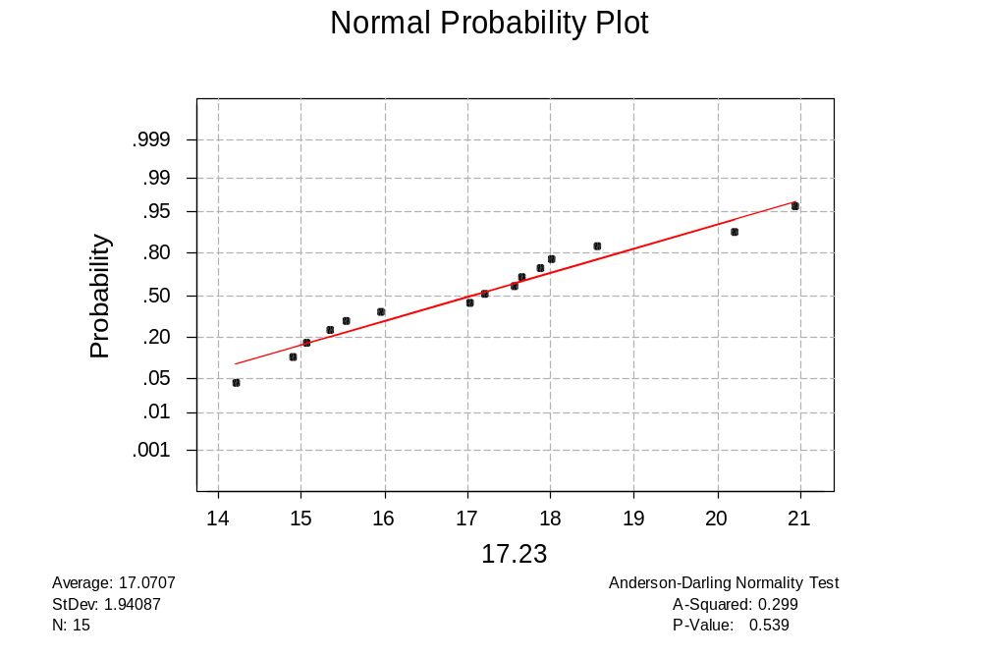

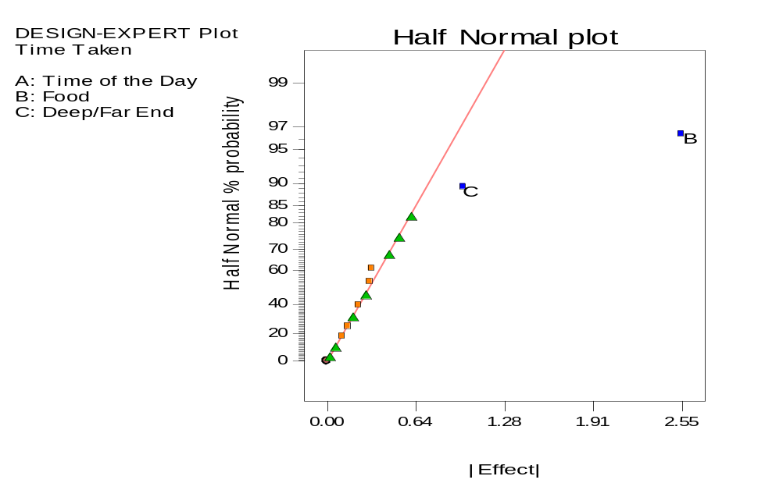
2:B:

2:C

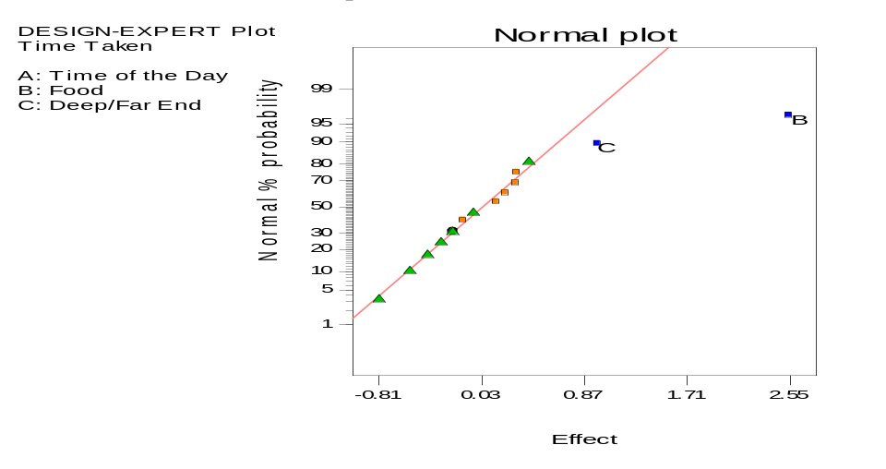

Appendix 3:
3 Factors: A, B, C
Design Matrix Evaluation for Factorial Reduced Main effects Model
No aliases found for Reduced Main effects Model
Degrees of Freedom for Evaluation
Blocks 1
Model 2
Residuals 12
Lack 0f Fit 12
Pure Error 0
Corr Total 15
Power at 5 % alpha level for effect of
Term StdErr** VIF Ri-Squared 1/2 Std. Dev. 1 Std. Dev. 2 Std. Dev.
Block 1 0.25
B 0.25 1.00 0.0000 15.2 % 45.2 % 95.6 %
C 0.25 1.00 0.0000 15.2 % 45.2 % 95.6 %
**Basis Std. Dev. = 1.0

Appendix 4:
Response: Time Taken
ANOVA for Selected Factorial Model
Analysis of variance table [Partial sum of squares]
Sum of Mean F
Source Squares DF Square Value Prob > F
Block 16.02 1 16.02
Model 29.91 2 14.95 26.25 < 0.0001 Significant
B 26.04 1 26.04 45.71 < 0.0001
C 3.87 1 3.87 6.80 0.0229
Residual 6.83 12 0.57
Cor Total 52.76 15

Appendix 5:
Std. Dev. 0.75
Mean 17.08
C.V. 4.42
PRESS 12.15
R-Squared 0.8140
Adj R-Squared 0.7830
Pred R-Squared 0.6693
Adeq Precision 14.671
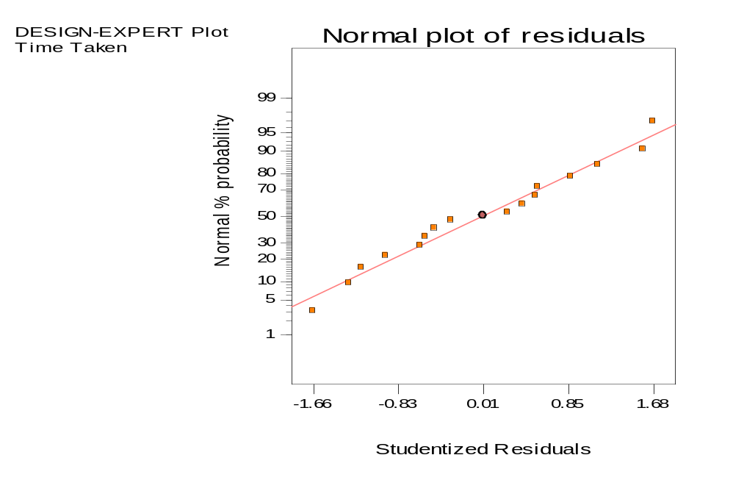
Appendix 6:
6:A:

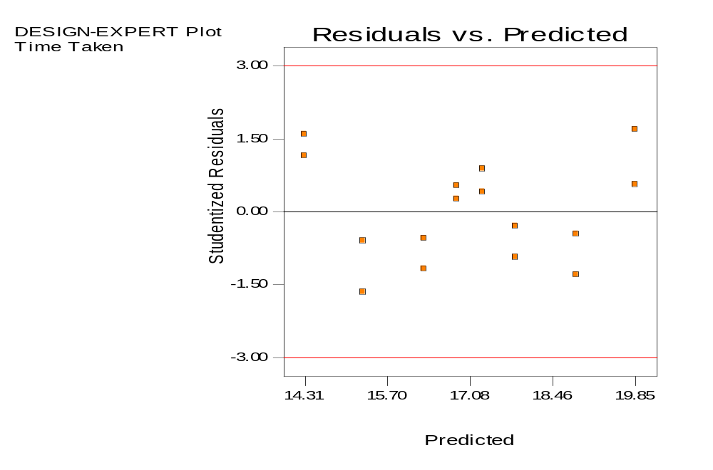
6:B

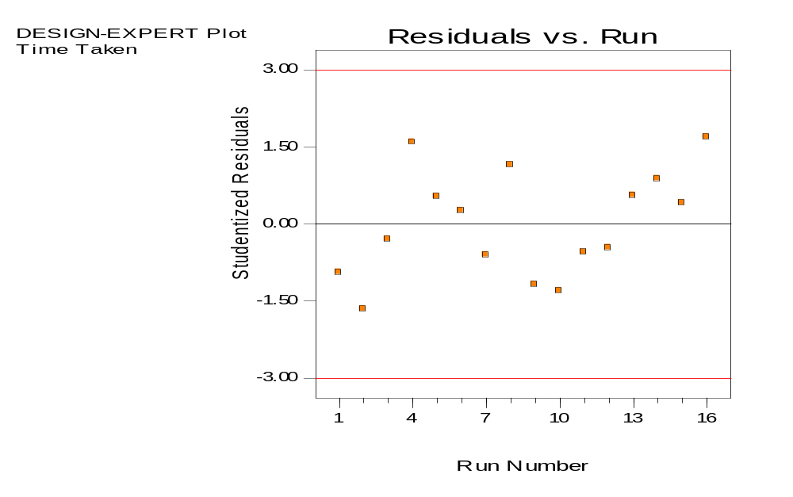
6:C:

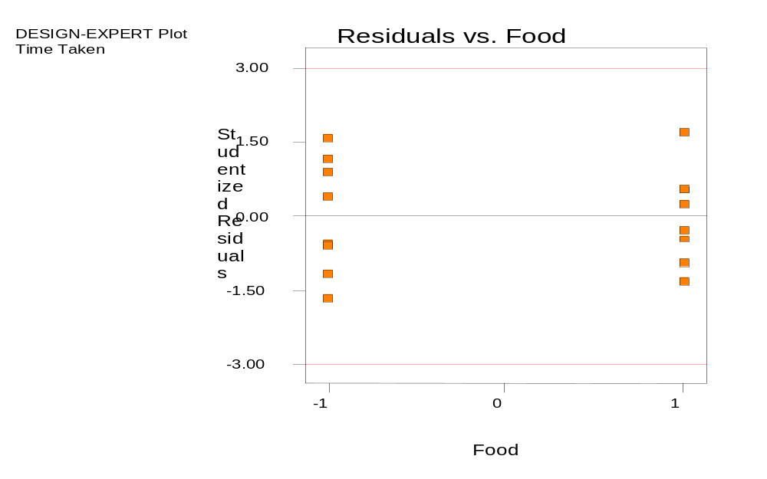6:D:

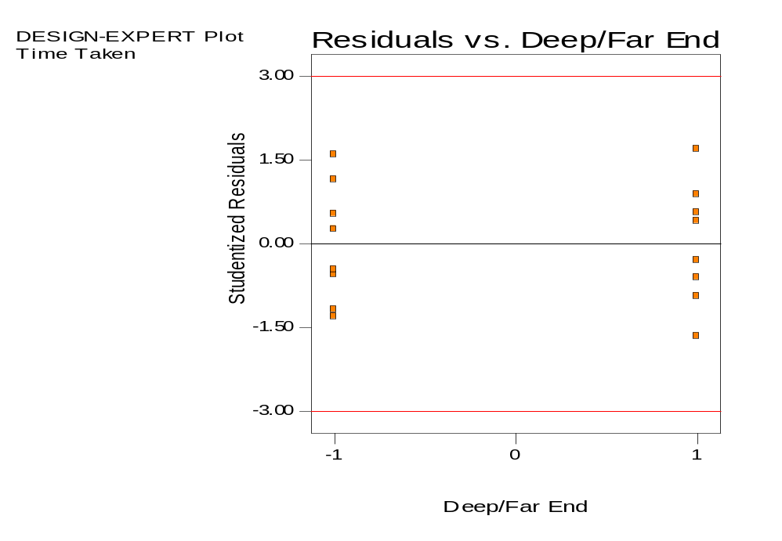
6:E

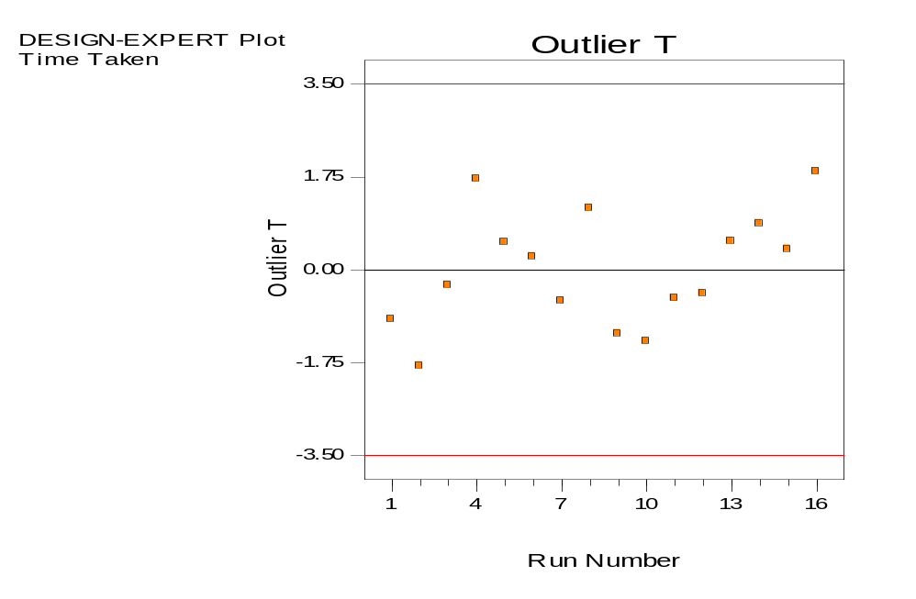
6:F:

Appendix 7:
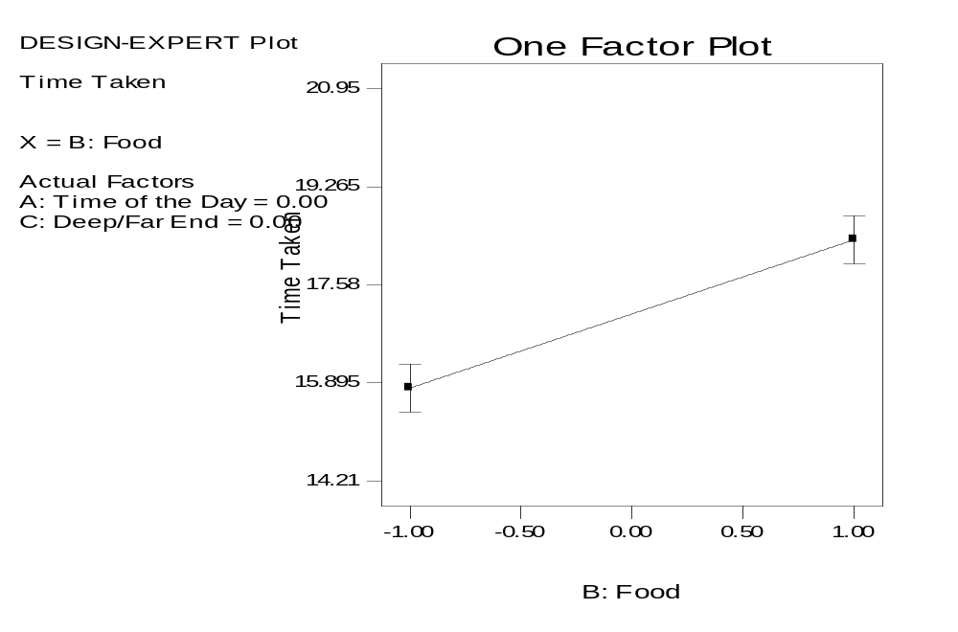
7:A:

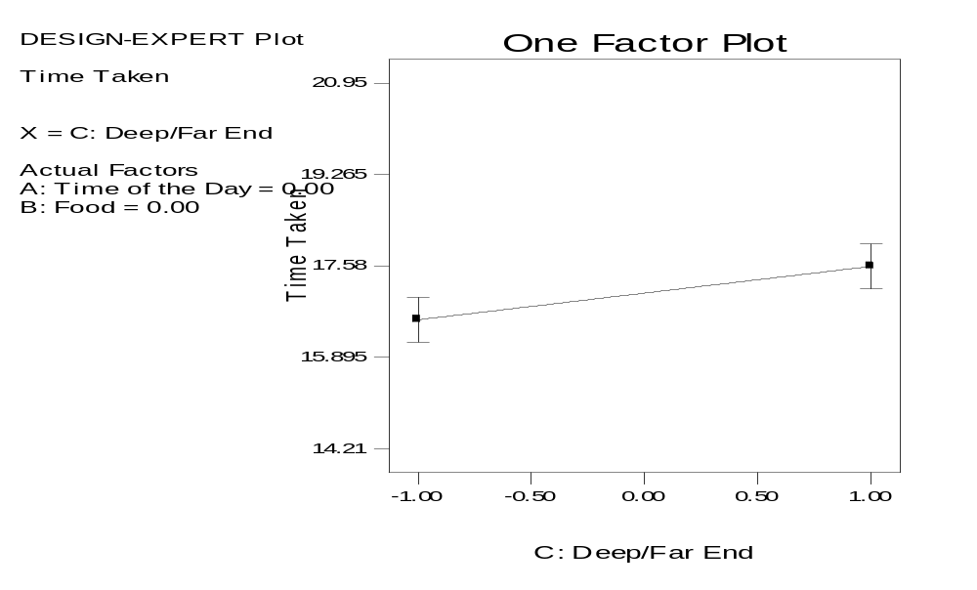
7:B:

